 ХИМИЧЕСКАЯ ИНЖЕНЕРИЯ ТРАНЗАКЦИИ  ТОМ xxx, 2026 | Публикация  
Итальянская ассоциация
химической инженерии
Онлайн по адресу www.cetjournal.it

Приглашенные редакторы: Флавио Маненти, Ботир Усмонов, Алессандро Ди Преторо.
Авторские права © 2026, AIDIC Servizi Srl
ISBN 979-12-81206-xx-x ; ISSN 2283-9216

Fine Grinding of Brown Coal in a High-Speed

Wedge-Rod Grinder with Discrete Macro-Roughness
Sultonov J. Valijonovich*ª, Nurmukhamedov Kh. Sadullaevich^{b,} *, Khairidinov M. Khamidovich^{c}, Nurmukhamedov S. Khabibullaevich^{d}, Sheralieva O. Anvarovna^{e}, Nigmajonov S. Karimdzhanovich^{f}
a,b,f,e Tashkent Institute of Chemical Technology, Uzbekistan, Tashkent.
c Center for scientific testing and quality control of Uzbekistan, Uzbekistan, Tashkent.
d “Uzkimyosanoat” JSC, Uzbekistan, Tashkent.
Sjv8904@gmail.com
This article presents the results of an experimental study on ultrafine grinding of locally mined brown coal in a turbo-blade, high-speed, impact-attrition apparatus. The grinder is unique in that it sequentially combines three zones—medium, fine, and fine—in a single apparatus, producing finely and ultrafinely ground fractions. Furthermore, the grinding elements are designed and manufactured in the form of a wedge with acute angles of 30° (zone "B"), 45° (zone "C"), and α=60° (zone "D"), with artificial macroroughness applied to the resulting sidewalls. The first parameter ensures impact grinding, while the second ensures attrition.
Experiments on grinding brown coal from the Angren deposit were carried out at an angular velocity of the working shaft with wedge-shaped rods of ω=114.3-228.5 s⁻¹ and revealed a significant influence of this parameter on the yield of finely dispersed fractions. At a pitch of the wedge-shaped rods t_{и}/d=0.6, an increase in the angular velocity from ω=114.3 to 228.5 s⁻¹ leads to an intensification of the process by 2.35 times, and the contribution of the relative roughness at ε=0.1276-0.27 ranges from 8.6 to 17.0%. Taken together, the influence of the above parameters ensures a more uniform fine grinding, i.e. if the initial raw material consisted of 9 fractions (0.25-15 mm), then after grinding the number of fractions decreased to 5 (0.05-0.5 μm). Moreover, the share of fractions up to 0.05 mm increased from 45.1% to 50.6% and, accordingly, the share of fractions up to 0.08 mm increased to 35.0%.
Research has shown that the organization of sequential grinding of brown coal in 3 stages in one apparatus ensures the production of solid hydrocarbon fractions suitable for gasification in fixed and fluidized beds, as well as in a dust flow with a particle size of less than 50 microns.
The production of finely and ultrafinely ground solid hydrocarbons opens up the prospect of producing coal-water fuel suspensions and their granules.
1. Introduction.
Currently, the fuel sector is the main one in the economy of any country. The latest statistics show that the fuel and energy sector accounts for ~10-15% of the world's GDP (Tashkent, 2020). Today, along with oil and natural gas, coal is actively used as a solid hydrocarbon for the production of combustible gas. This trend in the global energy balance is explained by the fact that expectations from nuclear energy obtained at nuclear power plants have not been met, and its share in the global energy sector is insignificant. Controlled thermonuclear fusion still remains at the laboratory research level. The most in-demand hydrocarbons are oil and gas, but their reserves are not unlimited and, at the current rate of consumption, they will be depleted by the end of this century. The current position of solid hydrocarbons in the fuel and energy balance is ~23%. It should be especially emphasized that 38-40% of electrical energy and 70% of steel are generated using coal (Patrakov Yu.F., 2005).
There are 4 main and large coal deposits in our country. These deposits are Angren, Shargun, Baysun and Kugitang (Khasilov Kh. et al. 2020). The largest in Central Asia is the Angren coal mine, the area of ​​which is ~70 km² (Khasilov Kh. et al. 2020). Currently, the methods of obtaining thermal and electrical energy by direct combustion of coal are outdated, their improvement is impossible due to the achieved maximum efficiency and pose major environmental problems (Zhuykov A.V. and Matyushenko A.I., 2020). To date, the processing of solid fuels into liquid and gaseous products for fuel and chemical purposes is extremely rare and is organized on an insignificant scale in industry [19]. However, intensive research is currently being conducted in the field of production of liquid and gaseous fuels from solid hydrocarbons. In this regard, an increase in coal consumption is expected by another 1 billion tons per year (Tsikarev D.A., 2004). Therefore, according to long-term forecasts of scientists in this area, there is a tendency for the world energy sector to switch to solid hydrocarbons, mainly coal. In addition to electricity, gasification is advantageously used in the production of organic products. In South Africa, the production of synthetic fuels from synthesis gas obtained by coal gasification using the Fischer-Tropsch method has already been established (Krichko A.A. et al., 1978). Recently, the most promising method is considered to be the processing of solid hydrocarbons to obtain them in a "liquid state." For this, coal is crushed to a fine fraction and mixed with liquid waste from oil refining, alcohols, water, and other waste from organic production (Gyulmaliev A.M., 2003). In this regard, it is logical that the gasification of solid hydrocarbons is a promising means of producing gas, without which it is difficult to imagine the efficient operation of enterprises in the chemical, gas processing, metallurgy, and energy sectors of the economy of any country. However, there are both negative and positive aspects of the gasification of solid fuels compared to liquid hydrocarbons: significant capital costs for the technology and gas purification from harmful substances. The positive aspects of coal gasification include the fact that gas purification before combustion is more economically advantageous than their separation from flue gases, especially nitrogen oxide. A "green economy" dictates the careful management and advanced processing of various ores and hydrocarbons. Coal, in particular, is a unique and distinctive mineral resource, consisting not only of combustible components but also containing rare and precious metals (Seredin V.V et al. 2013, Ketris M.P et al. 2009).
Today, coal, a solid hydrocarbon, is an important energy resource that plays a significant role in the global economy. It should be considered as an energy-technological raw material, and its use on a large scale should be comprehensive, dividing its potential chemical energy approximately equally between energy products (electricity and heat) and chemical products. Most countries in the world, in the field of coal policy, are deliberately transforming the industry from a raw material industry to an industry of deep processing of solid hydrocarbons, especially brown coal (Gaibullaev Z.Kh. et al., 2023). This trend makes it possible, instead of direct combustion of coal, to gasify solid hydrocarbons, to obtain gaseous and liquid fuels, as well as various products, such as coke, activated carbon, sorbents, resins, carbon fibers, motor fuel, wax, gas, etc., with high added value (X. Wu, 2004, R. Guo, 2005 Zhou, H, 2004, Nikolaeva, S.V, 2009). Consequently, research in the field of creating environmentally friendly technologies for the deep processing of solid hydrocarbons with the aim of obtaining liquid and gaseous fuels remains a promising area (Saryglar, Ch.A., 2018). The importance of this area is also determined by the Paris Climate Agreement (2015), which requires the reduction of greenhouse gas emissions and the creation of low-carbon technologies (Paris, 2015; Suleimanov K.A. et al., 2020). Today, China is the world leader in the field of processing brown coal into synthesis gas, from which environmentally friendly synthetic liquid fuels are subsequently obtained for various vehicles (Chonga Yu.Si et al., 2020; Wang Y., Liu W., 2020).
Thus, in China there are 48, in South Africa - 40 and in the USA, there are only 14 large brown coal gasification enterprises. Despite the existing diversity of gasification methods (Ronald W. Breault, 2010), the problem of highly efficient use of solid, especially low-reactivity fuels, at thermal power plants has not yet been solved. However, its use is associated with a number of environmental problems, which requires the development of cleaner and more efficient technologies for coal combustion and the search for alternative energy sources (Yusupkhodzhaeva F.D., 2025). All gasification technologies use a fraction of finely ground coal, which in turn dictates the creation of processes and equipment that provide the necessary fraction for its thermochemical processing.
U.S. Patent № 2,078,933 is known, which proposes a method for crushing coal by pre-saturation with water followed by steam-thermal treatment at a pressure of 1.4 MPa (USA №2078933). In a confined space, the micro- and macropores and cracks of the coal are filled with water vapor, after which the pressure is immediately released into the surrounding environment. At this moment, the superheated moisture boils and steam is directed from the solid body outward, which is accompanied by a popping sound. Disadvantages include: the periodicity of the process; significant energy costs associated with high steam pressure; the impossibility of subsequent use of the energy of saturated steam.
In Russian patent №1763016, grinding is accomplished by passing the object being processed through a plasma torch (RU №1763016). The disadvantages of this method are that the high-temperature jet melts small particles, grinds medium-sized ones, and does not crush large ones under the action of boiling liquid phase; objects such as coal enter into a chemical reaction with the high-temperature jet.
A disintegrator design has been developed whose operating principle is based on the fact that when the end stators of an asynchronous electric motor are connected to alternating current, the rotors begin to rotate in opposite directions (RU №2109568). This is explained by the creation of magnetic fields by the windings rotating the stator, as well as eddy currents. The resulting rotating magnetic fields drive rotors in the form of disks, which are positioned opposite one another. Grinding occurs when the rotors rotate in opposite directions. This rotation of the rotors is achieved by alternating the voltage phases for each stator winding.
The advantages of the proposed disintegrator design include: compactness; broad functionality, i.e., parallel sectioning increases productivity; and sequential connection of sections allows for a high degree of grinding and homogeneity of the finished product.
Disadvantages of this design of the grinder: each section is equipped with two electric motors, and the multi-section design leads to increased energy costs (RU №2109568).
A shredder has been developed consisting of a housing containing two coaxially rotating disks connected to electric motors (RU №2438782). The left disk has radial accelerator blades, and the inner surface of the housing is designed as a deck. The disks are designed with alternate recesses and projections. The projection of one disk fits into the recess of the other disk, creating a gap. The disks rotate in opposite directions, creating counter-rotation. The advantages of this device include efficient shredding and high productivity.
A disadvantage of this device is its high energy consumption (RU №2438782).
Gorobets L.Zh. and his colleagues conducted research on the crushing of ores and, in order to predict the modes and indicators of crushing over time, proposed a pattern of destruction or what is called the dynamic size effect (Gorobets L.Zh at all).
A device designed for breaking hard materials is proposed, which is capable of driving a rotating cutting element and a counter-cutting plate adjustable relative to it (RU №2497346). Disadvantages of this design: the knives often become dull, and operational difficulties also arise.
A device for crushing materials has been developed, which contains a housing with a loading nozzle, an auger connected to a shaft, and a cutting element consisting of a knife and a grate (RU №2313397). Disadvantages: the pendulum pusher complicates the design of the crusher, and during operation, play reduces the efficiency of crushing.
A centrifugal impact crusher is also known, in which the left and right discs are coaxially located in the crusher body, with annular grooves in the form of alternating triangular protrusions and trapezoidal depressions in the radial section of the disc, on which knives are mounted (RU №2350388). The protrusions of one disc enter the depressions of the other, forming a gap, and are coaxially secured to the shafts of electric motors with the ability to rotate in opposite directions, ensuring their counter-rotation.
The disadvantages of this design include low productivity and high energy consumption. Furthermore, the need for frequent sharpening of the knives and a decrease in finished product productivity.
One of the promising and effective methods is the crushing of brown coal by combining impact and abrasion, which is advisable to implement in a turbo-blade crusher of the impact-attrition type (Abdullaev A.Sh., at all 2013).
Experimental setup and methodology.
The laboratory setup for crushing brown coal consists of a three-zone turbo-blade crusher, a shaft rotation control system with rods, and a feedstock feeder.
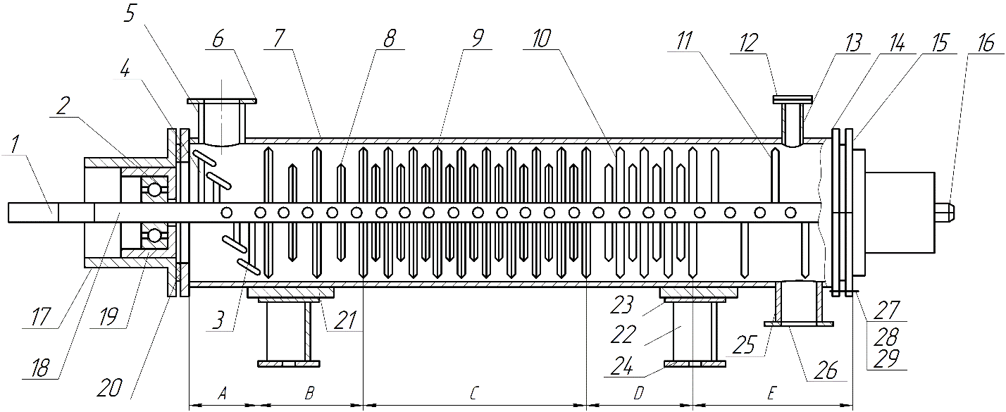
The turbo-blade crusher of the impact-attrition type belongs to the class of impact-centrifugal devices and is designed from 5 zones: A - loading zone; B - coarse crushing zone; C - fine crushing zone; D - fine crushing zone; E - unloading zone (UZ № 20220609). ” (Figure. 1) (Annaev N.A., 2023, UZ № 20220609). Another special feature of this device is that above the unloading nozzle of zone “E” a classification nozzle is installed in order to select particles of the smallest fine fraction.

Figure. 1. Turbo blade crusher for solid materials.
1-left part of square section shaft; 2-bearing; 3-blade; 4,11-round rods; 5,13-nozzles; 6,12-flanges; 7-housing; 8,9,10-wedge-shaped rods; 14,15-flanges; 16-right part of round section shaft; 17-sleeve; 18-hollow part of shaft; 19-cup; 20-gasket; 21-base; 22-support; 23-segment sheet; 24-support sheet; 25-discharge nozzle; 26-flange; 27-bolt; 28-nut; 29-washer.
A - loading zone; B - coarse grinding zone; C - fine grinding zone; D - fine grinding zone; E - unloading zone.
When grinding brown coal, the operating and geometric parameters of the working shaft with rods varied in the following range: angular speed of shaft rotation ω=114.3-228.5 s⁻¹; pitch of the rods in the fine grinding zone t_{и}/d=0.6; relative roughness of the sides of the rods ε=△/d_{e}=0.27, where △ is the height of the roughness, mm; d_{e} is the equivalent diameter of the rod, mm.
The turbo-blade impact grinder consists of a cylindrical body 7 mounted on two supports 22, within which a shaft 18 with wedge-shaped rods 8, 9, 10 and round rods 4, 11 is located along the horizontal axis. The cylindrical body is made of Kh18N10T stainless steel with a diameter of 0.150 m, a thickness of 0.006 m, and a length of 1.5 m.
The shaft 18 is rigidly connected to the left part of the solid shaft 1 with a square cross-section and to the right part with a round cross-section 16, secured on bearings 2 and seated in a cup 19, which rotates on a sliding fit inside the bushing 17. The shaft is rigidly mounted on bearings and seated in a cup, which on a sliding fit is capable of both rotating and moving inside the bushing.
The wedge-shaped shaft rods are arranged to form zones of medium, fine, and fine grinding. The rods are tapered at angles of 30°, 45°, and 60°, respectively, and feature discretely spaced transverse irregularities relative to the direction of the material being ground, creating a micro-rough surface on both sides of the rods. The speed of the DC electric motor is regulated by a specially designed panel with a frequency converter. The speed of the shaft with the grinding rods was determined using a DT2234C contactless digital tachometer, the measurement accuracy of which is ±0.05% (Sultonov Zh.V. et al., 2026).
The fractional composition of particles over 50 μm was determined by sieve analysis using a well-known technique (ISO 2325:86, Klassen P.V 1990). The average diameter of the fractions was determined as the arithmetic mean of the maximum and minimum particle diameters. The granulometric composition of the fraction <50 μm was determined in an Eijkelcamp apparatus with a TALOS F200i transmission electron microscope; the TEM line resolution was ≤10 nm, the TEM information limit was ≤12 nm (S-FEG/XFIG) and ≤11 nm (S-CFG), and the STEM resolution was ≤16 nm (S-FEG/XFEG) and ≤14 nm (X-CFEG), which allows for express analysis with minimal error (https://mn-lab.uz/catalog/prosvechivayuschie-elektronnye-mikroskopy/prosvechivayuschiy-elektronnyy-mikroskop-talos-f200i).
Experimental study results.
Experimental studies on fine and ultrafine crushing of brown coal from the Angren coal quarry were conducted in a high-speed turbo-blade apparatus. The pre-crushed brown coal consisted of nine fractions with particle sizes ranging from 0.25 to 15 mm. The granulometric composition of the original brown coal is as follows: the fraction up to 1.0 mm is 0.2%, the proportion of particles 0.5-1 mm is only 1.3%, the fraction in the range of 1.0-1.5 mm in the amount of 6%, the fraction of 1.5-2.5 mm was 5%, the amount of particles 2.5-5 mm is only 5%, the proportion of 5.0-7.0 mm is only 31%, the proportion of the fraction 7.0-10 mm is 18%, the proportion of the large fraction 10-12 mm is 25% and the proportion of the fraction 12.0-15.0 mm is 8.5% (Figure. 2a).
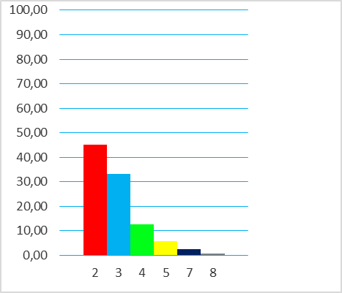
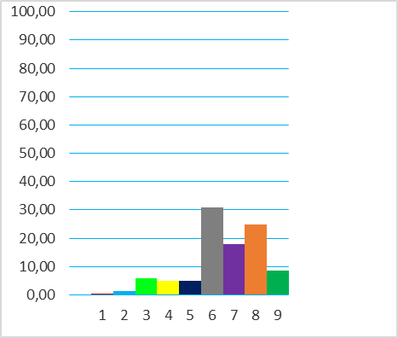
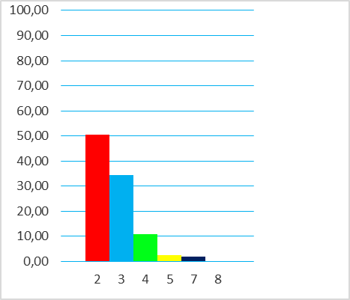
R, %
d_{э}, мм
60
40
20
0
0,05
80
100
0,08
0,16
0,315
0,5
1,0
R, %
d_{э}, мм
60
40
20
0
0,5
80
100
1,0
1,5
2,5
5
7
10
12
15
R, %
d_{э}, мм
60
40
20
0
0,05
80
100
0,08
0,16
0,315
0,5
1,0

Figure. 2. Particle size distribution of the original (a) and crushed
brown coal in a turboblade crusher (b, c).
b - ω=202.7 s⁻¹; c - ω=228.5 s⁻¹.

Crushing in a turbo-blade grinder allowed us to obtain a qualitatively new product with the following parameters: if the initial raw material had 9 fractions (Fig. 2a), then after crushing at a pitch of the wedge-shaped rods on the shaft in the fine grinding zone of ti/d = 0.6 and an angular velocity of the shaft of ω = 202.7 s⁻¹, the number of fractions decreased to 6 (Figure. 2b) and at ω = 228.5 s⁻¹, respectively, to 5 fractions. (Figure. 2c). A characteristic feature of the grinding process in a turbo-blade apparatus is that all fractions after fine grinding have a maximum particle size of <1 mm, i.e., all fractions can be used in gasification in a dust stream.
An analysis of Fig. 1b and 1c shows that the sum of the 0.05- and 0.08-mm fractions is 78.4 and 85.0%, respectively. Moreover, the fraction up to 0.05 mm dominates in this mixture, with its content being 45.1 and 50.6%, respectively. A comparison of the data on the particle size distribution depending on the angular velocity ω of the working shaft rotation shows that an increase in ω from 202.7 to 228.5 s⁻¹ contributes to an intensification of the grinding process by 12.2%, and the share of the fraction up to 0.05 mm reaches 50.6%.
After grinding in a high-speed centrifugal impact grinder with a rod spacing of ti/d = 0.6, only five fractions with particle sizes ranging from 0.05 to 1.0 mm were formed in the fine grinding zone. The shift toward fine particles is significant, indicating that the process is highly efficient, as all solid hydrocarbon fractions in this region are smaller than 1.0 mm.
The emphasis on fractions with these sizes is due to their potential use in the gasification of solid hydrocarbons to produce syngas. Furthermore, grinding brown coal into finely dispersed fractions allows for the production of coal-water fuel slurries, which offer potential for pipeline transportation and use as combustion fuel.
Experimental studies have shown that increasing the angular velocity from 114.3 to 228.5 s⁻¹ increased the number of particles in the 0.05- and 0.08-mm size ranges by approximately three times. The high efficiency of the grinding process in a three-stage turbo-blade impact-attrition grinder is due to the simultaneous action of two grinding modes: constrained impact and attrition. It is particularly noteworthy that in the ultrafine grinding zone, the attrition mode dominates over constrained impact.
Conclusion.
Research on brown coal grinding in a three-zone turboblade apparatus demonstrated the feasibility of producing fine particles corresponding to ultrafine grinding. Furthermore, the use of wedge-shaped rods with discretely arranged vertical grooves creating macroroughness enabled a grinding degree of i ≥ 300 to be achieved. The proportion of particles sized 0.08 mm and smaller accounted for 85%, while the maximum particle size of the remaining fractions did not exceed 0.5 mm. A significant reduction in the equivalent diameter of the ground particles is accompanied by an increase in the specific surface area of ​​the particles, which positively impacts the intensity of subsequent heat and mass transfer, as well as thermochemical processes.
Thus, the technical and economic advantages of the proposed apparatus are: compactness; high productivity; obtaining particles of uniform size; improving the fractional composition and marketable appearance of the product; the possibility of organizing preliminary classification of crushed materials; eliminating pollution of nearby areas with a fine fraction; and adaptability to the conditions of mechanical engineering enterprises in our country.

Literature

Annaev N.A., Nurmukhamedov H.S., Sultonov Zh.V. et al. Granulation – design of solid particles / Tashkent: TKhTI, 2023. – 210 p.
Abdullaev A.Sh., Nurmuhamedov H.S., Abdullaeva S.Sh. Issue of non-traditional clearing roots // USA, The advanced science, 2013. - No. 5. ¬- p. 81-84.
Chonga Yu.S., Parkb K.B., Kim J.S. Hydrogen production by steam gasification of polyethylene using a two-stage gasifier and activated carbon. Applied Energy, 262 (2020), 114495. Available at: https://doi.org/10.1016/j.apenergy.2020.114495.
Evaluation approach of operating status for Texaco coal gasification process based on extension and fluzzy theory / R. Guo [et al.] // Journal of chemical Engineering of Chinese Universities. - 2005. - Vol. 19. - No. 1. - P. 77-83.
Electronic resource https://mn-lab.uz/catalog/prosvechivayuschie-elektronnye-mikroskopy/prosvechivayuschiy-elektronnyy-mikroskop-talos-f200i
Gaibullaev Z.Kh., Karamirzaev G.Kh., Gadoev T.Kh. Modeling of the coal gasification process / Int. Atomic Energy Agency, 2023. - 5 p.
Gyulmaliev A.M., Golovin G.S., Gladun T.G. Theoretical Foundations of Coal Chemistry. - Moscow: Moscow State University Publishing House, 2003. - 556 p.
Gorobets L.Zh., Pryadko N.S., Shulyak I.A., Verkhorobina I.V. Theoretical justification for energy-saving modes of mineral processing // Publishing house Education and Science sro.
GOST 5954.2-2020 (ISO 2325:86). Coke. Sieve analysis of size class less than 20 mm.
Information and Analytical Center “MINERAL”. Available at: http://www.mineral.ru/infoblock/misc/greatest_dep.html - access date: 01.03.2012.
Krichko A.A., Lebedev V.V., Farberov I.L. Non-fuel use of coal // Moscow: Nedra. - 1978. - v.215. - p.36.
Khasilov H., Omonov H., Abdullaev H., Ochildiev A., Normurodov Sh. Prospects of the coal industry of Uzbekistan / Silk Road Transport, 2020.-№1.-pp.10-16.
Ketris M.P., Yudovich Ya.E. Estimations of Clarkes for Carbonaceous biolithes: World averages for trace element contents in black shales and coals // Int. J. Coal Geol. - 2009. - V. 78. - P. 135-148.
Klassen P.V., Grishaev I.G. Basic processes of mineral fertilizer technology. - Moscow: Chemistry, 1990. – 304 p

Modelling on the effects of operation parameters on entrained flow coal gasification. Model prediction and analysis / X. Wu [et al.] // Journal of Zhejiang University (Engineering science). - 2004. - Vol. 38. - No. 11. – Р. 1483-1489.
Nikolaeva, S.V. Modern processes of coal processing / S.V. Nikolaeva, F.N. Latypova, S.Yu. Shavshukova // Bashkir chemical journal. – 2009. – No. 3. – P. 123-132.
Patrakov, Yu.F. Status and prospects of deep coal processing processes // Chemistry for Sustainable Development, 2005. - No. 13. – pp. 581-585.
Paris Agreement. – Paris, December 12, 2015. – 32 p. https://unfccc.int/sites/default/files/russian_paris_agreement.pdf
Patent USA №2078933. Pulverizing mineral aggregates. Reginald S. Dean, Washington D.C. and Jonh Gross. Minneapolis, Minn. May 20, 1982. Serial N612524 (cl. 83-94).
Patent application IAP No. 20220609. High-speed apparatus for grinding pelletized materials / Annaev N.A., Nurmukhamedov Kh.S., Karimov K.F., et al. / Ichthyrol. Rasmium akhborotnoma. Prior. from 30.01.2022. – ill. 4. – 21 p.
Ronald W. Breault "Gasification Processes Old and New: A Basic Review of the Major Technologies" // Energies 2010.-№ 3.-P. 216–240; doi: 10.3390/en3020216.
24. Patent of the Russian Federation №1763016. MKP5 B02C 19/18. Method for processing wet materials / Anisimov V.V., Parsia F.A., Altukhov V.N., Shurin N.V. / publ. 23.09.1992, Bulletin No. 35. – ill. 1.-p. 1.
Russian Federation Patent No. 2109568. MKP6 B02S 13/22. Disintegrator / Gaitov B.Kh., Kopelevich L.E., Gaitova L.M., Gaitova T.B., Avtaikin I.N., Popov S.A. / published 27.04.1998, Bulletin No. 12. – ill. 3.-p. 2.
Russian Federation Patent No. 2438782. MKP6 B02S 7/02. Device for grinding bulk materials / Trufanov V.V., Opryshko V.M., Yarovoy M.N., Druzhinin R.A. / published 01/10/2012, Bulletin. No. 1. – ill.2.- 5 s.
Russian Patent No. 2497346. IPC 8 A23A 3/00. Crushing apparatus / Brokhan-Ludemann Sh., Roggenland M. - ill. 3. - 17 p.
Russian Patent No. 2313397. IPC 7 B02C 18/30. Device for grinding products / Valeev R.R., Valeev I.R., Tsenev N.I., Mitrofanov O.A., Tsenev A.N. - ill. 1. - 9 p.
Russian Patent No. 2350388. IPC 7 B02C 7/02. Impact-centrifugal grinder / Trufanov I.I., Opryshko I.M., Lyapin V.M. – ill. 2. – 5 p.
Seredin VV, Dai S., Sun Y., Chekryzhov Yu I. Coal deposits as promising sources of rare metals for alternative power and energy-efficient technologies // Applied Geochemistry. - 2013. - Vol. 31. - P. 1–11.
Saryglar, C.A. Main directions of coal processing / Ch.A. Saryglar, R.B. Chisyma. // Fundamental research. – 2018. - No. 11. - P. 121-127.
Suleimanov K.A., Kaspiev A.G., Ismailov A. Experimental setups of the laboratory "clean coal technologies" / Coal Thermal Power Engineering in Kazakhstan: Problems. Solutions. Development Prospects. Almaty, 2020. - pp. 139-145.
Sultonov Zh.V., Nurmukhamedov Kh.S., Mavlonov E.T. et al. Khayridinov Kh.A. Influence of the angular velocity of rotation of the working shaft on the degree of grinding of solid hydrocarbons // UNIVERSUM: Technical sciences, 2026. - issue No. 4 (145). - pp. 4-12.
Tsikarev D. A. New strategies in coal chemistry and coal energy // Coke and Chemistry, 2004. - No. 9. - P. 42-43.
Yusupkhodzhaeva F. D., Gulomova G. M., Yusupkhodzhaeva E. N. Comparative analysis of brown and hard coal / International Journal of Science and Technology, 2025. - vol. 2. - ussue 2. - p. 122-127.
Wang Y., Liu W. Production of syngas by steam gasification of three different types of coal and the kinetics of the corresponding reactions / Journal of the Power Engineering Institute, 2020. - No. 93. - pp. 533-541.
Zhukov AV, Matyushenko AI. Methods for producing and applying synthesis gas // Journal of the Siberian Federal University "Engineering and Technology", 2020. - No. 13 (4). - pp. 383-405.
Zhou, H. Experimental study of coal partial gasification in a fluidized bed / H. Zhou, Z. Zhong // Journal of Engineering for thermal energy and power. - 2004. - Vol. 19. - No. 3. - P. 252-255.

